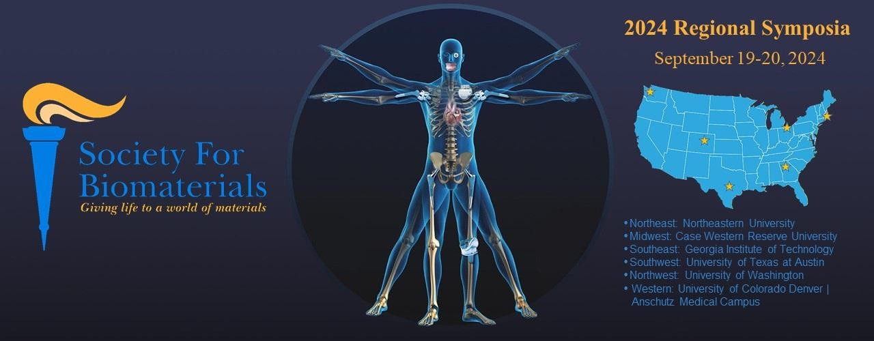

Northwest Location: University of Washington, Seattle Sponsorship

Platinum Sponsor - $3,000
- Recognition on regional conference program/website (choose: sidebar/footer/display ad)
- Four mentions with company name and logo on UW BioE social media
- Three registrations for company representatives
- Exhibit booth space provided at the conference
- Recognition during opening and closing remarks
- Shared logo exposure at Food and Beverage areas

Gold Sponsor - $1,500
- Recognition on regional conference program/website (choose: sidebar/footer/display ad)
- Two mentions with company name and logo on UW BioE social media
- Two registrations for company representatives
- Exhibit booth space provided at the conference
- Recognition during opening and closing remarks

Silver Sponsor - $750
- Recognition on regional conference program/website (company logo)
- One mention with company name and logo on UW BioE social media
- One registration for company representatives
- Exhibit booth space provided at the conference
- Recognition during opening and closing remarks

Bronze Sponsor - $500
- Recognition on regional conference program/website (company logo)
- One mention with company name and logo on UW BioE social media
- One registration for company representatives
- Recognition during opening and closing remarks

Student Travel Awards - $200 each
- Company-branded student travel award
- Recognition on regional conference program/website (company logo)
- Each award will provide free registration to one student

